About Hacking Club
Hacking Club is a platform to learn cybersecurity, an incredible resource if you don’t know where to start. In addition to vulnerable machines, you have access to classes and challenges to practice your skills and access to an exclusive community to play and challenge yourself.
The best part about Hacking Club is that it is very hands-on. If you are new to hacking, give it a try.

Introduction

This write-up refers to the BIN TRUNK machine.If you require support, please open a ticket in the support channel on the Discord server.

Nmap Scan:
As a first step, we need to determine which services are running in the background and which ports are open. Therefore, we will use a tool called nmap.
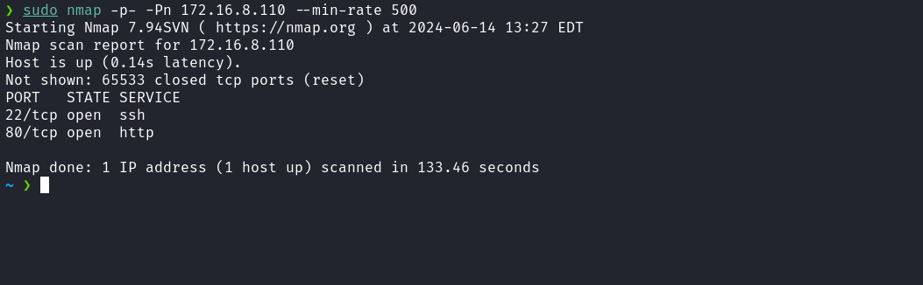
We observed the presence of port 80 hosting a web service and port 22 corresponding to SSH. When accessing the application, we see a message stating that the API is under construction and that we can view the source code by clicking a button, which redirects us to gitea.bintrunk.hc.
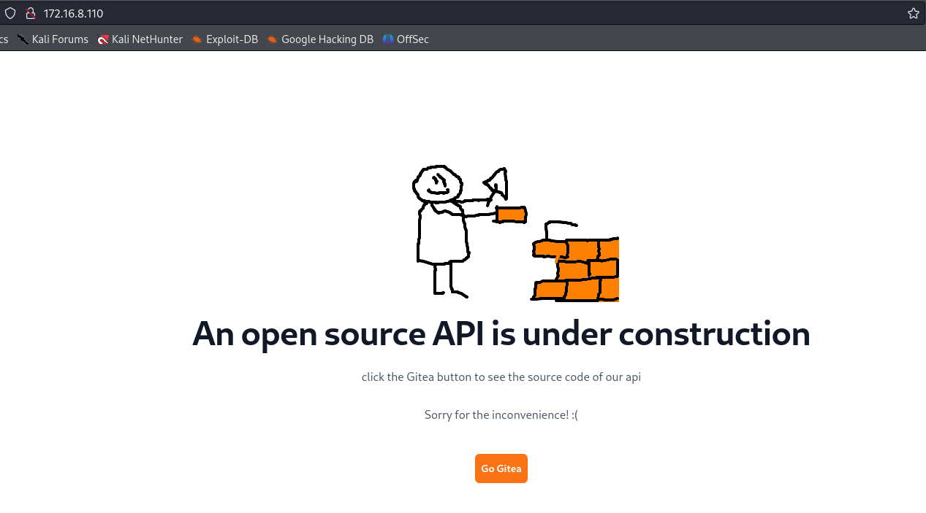

To access the subdomain gitea.bintrunk.hc, it is necessary to map the IP address to the domain name by adding an entry to the hosts file, as demonstrated in the image below.
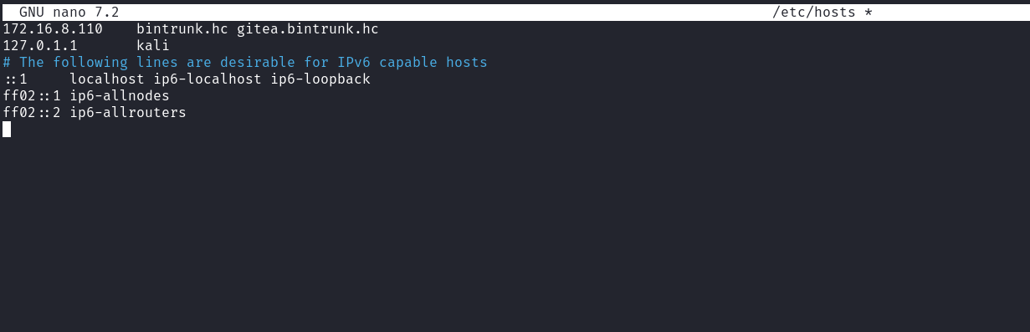
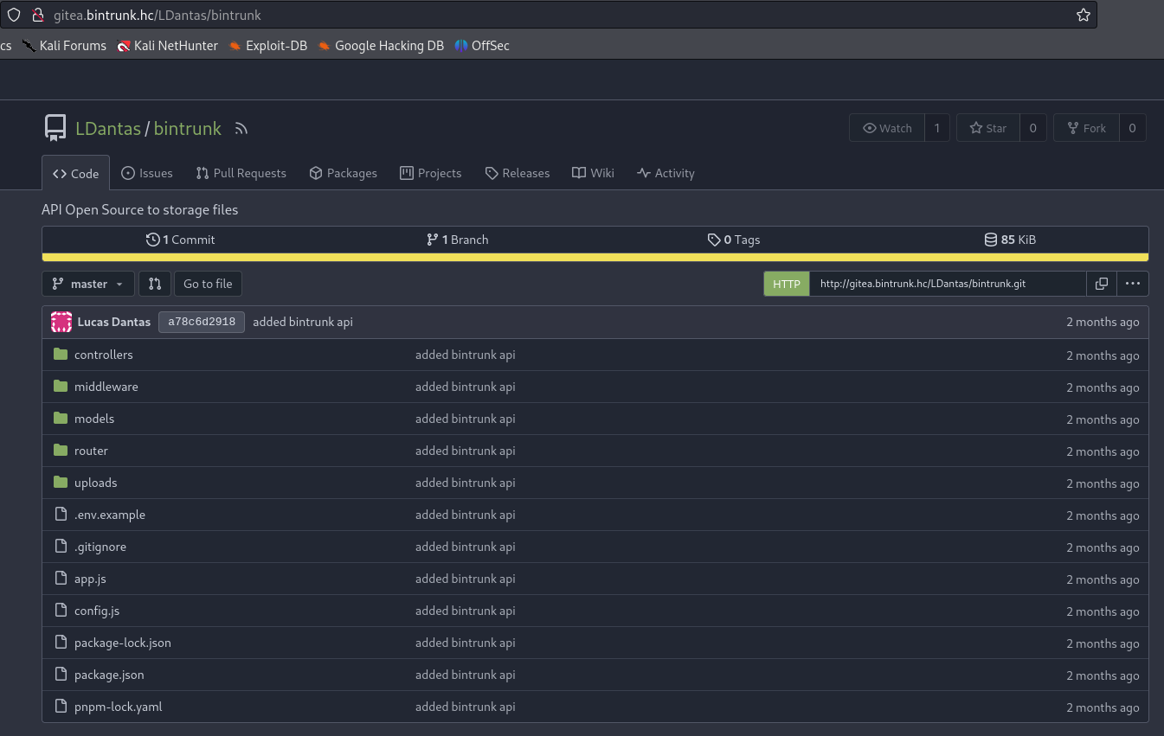
Now we need to perform subdomain enumeration in order to access the API routes.
Using the ffuf tool with the shubs-subdomains.txt wordlist from SecLists, we were able to find the subdomain related to the API. Note that we used the -mc all option to return all status codes, since the root route (/) of the API does not return content, only the status code 404, which could prevent detection without this option.
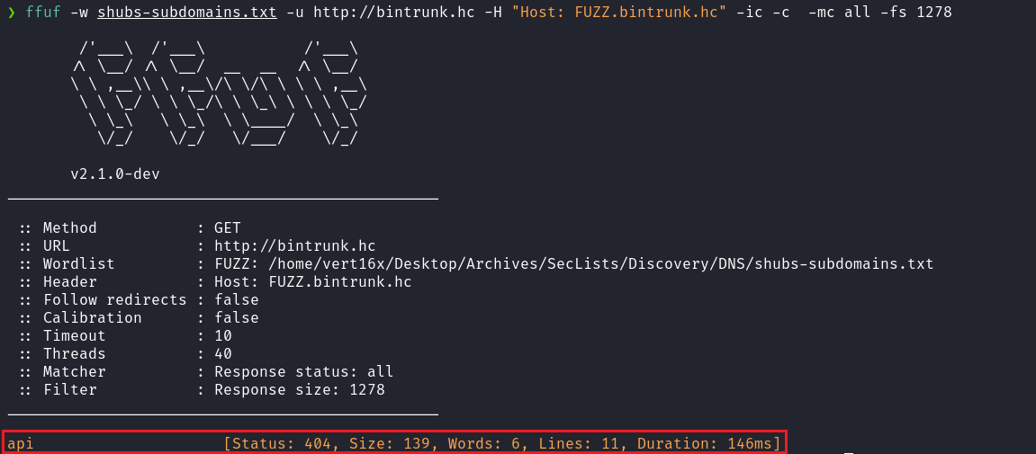
Now we need to add this subdomain to the hosts file.
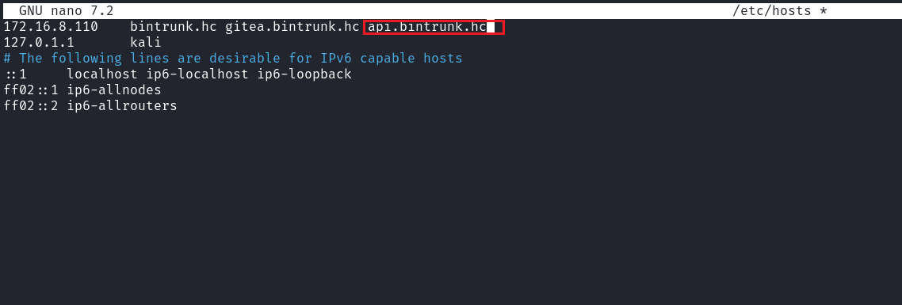
By reading the file /controllers/api/v1beta/users.js, we observe that it is possible to list the API users. However, to access this route, it is necessary to register a user, since it is protected by middleware that requires authentication.
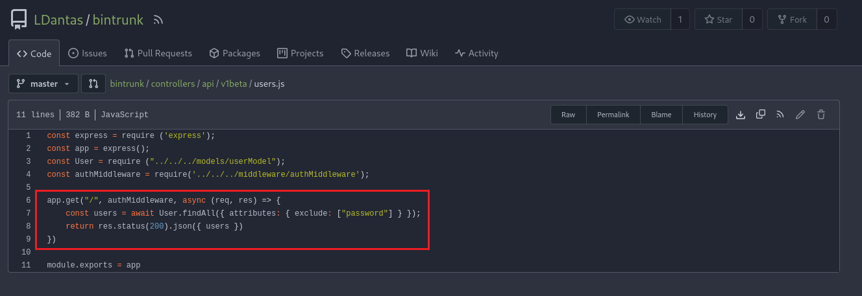
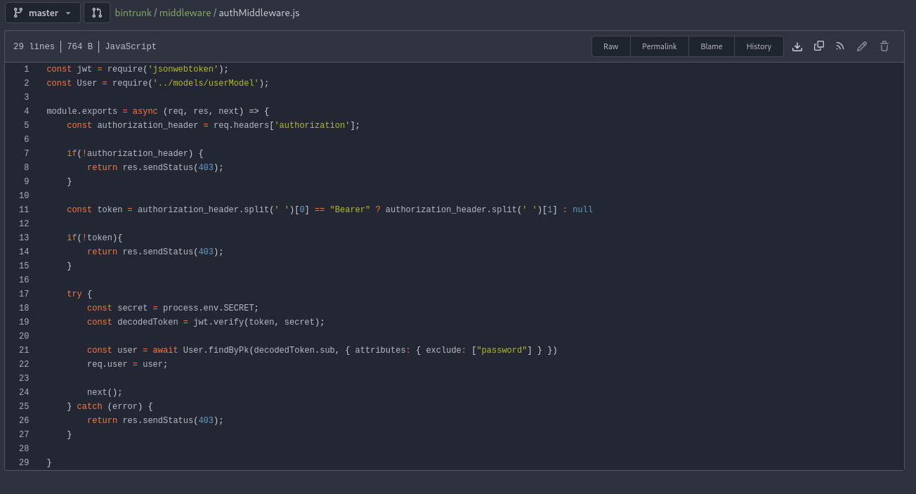
When analyzing the file /controllers/api/auth.js, we notice that three parameters are required: username, email, and password. By checking the file /controllers/api.js, we identified that we need to make a POST request to /api/auth/register, passing these three parameters.
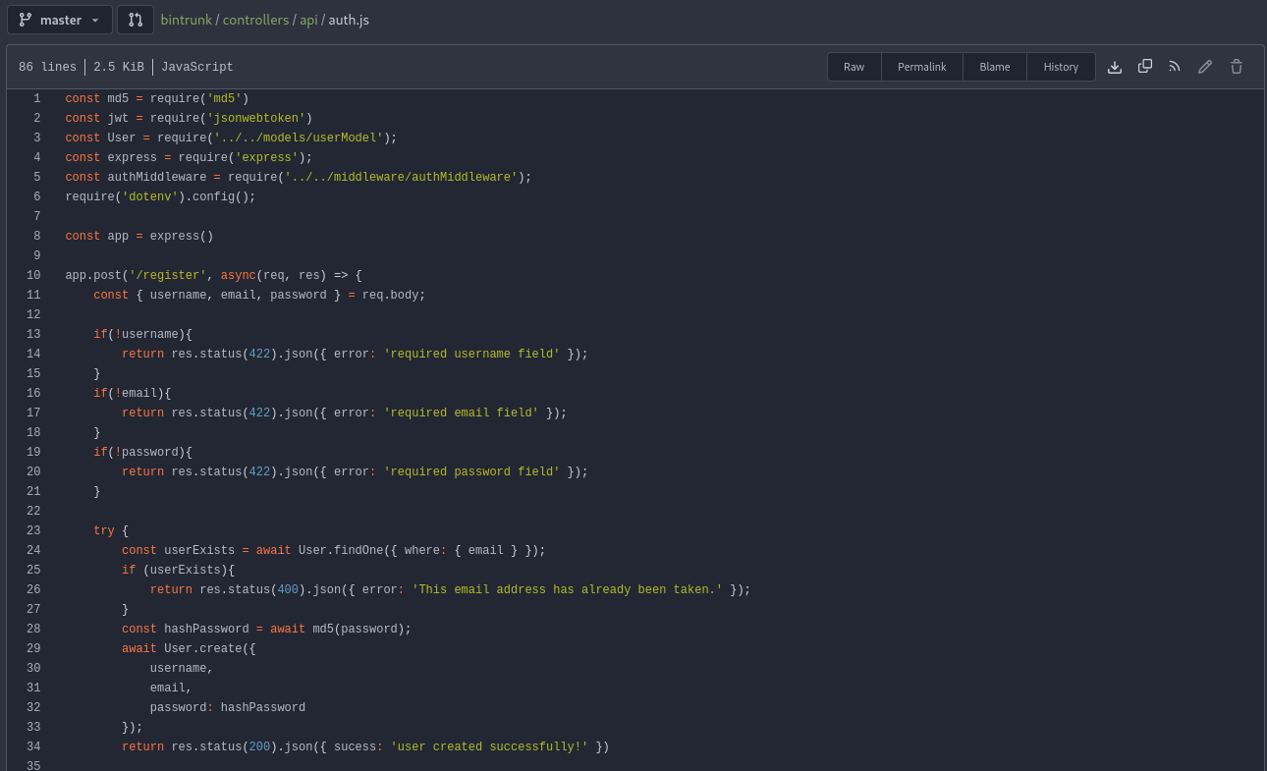
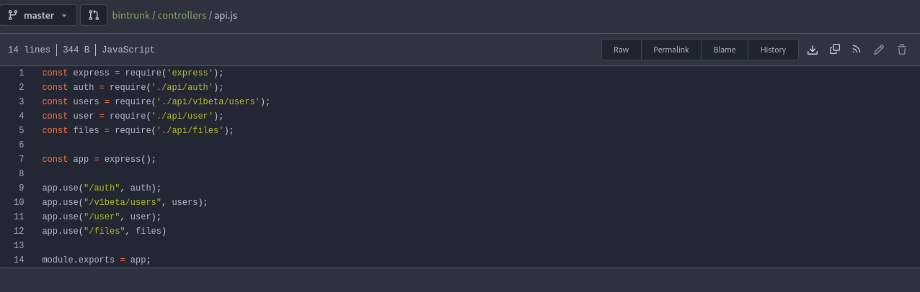
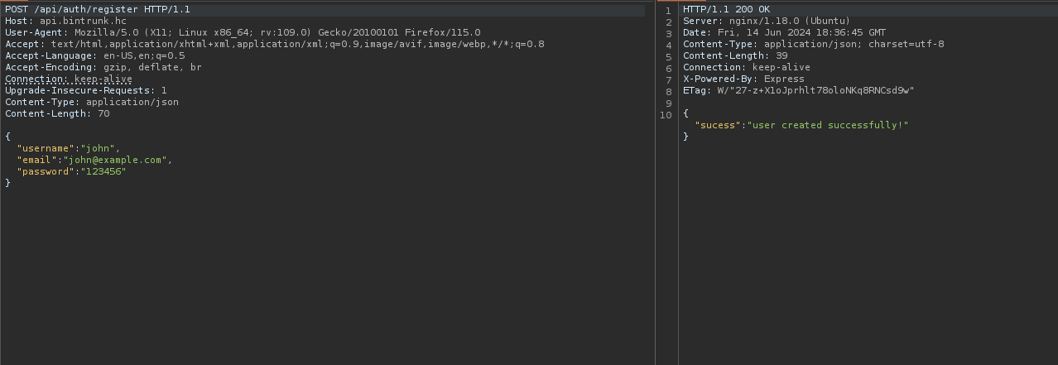
After registering a user, we need to log in to obtain the token. By reading the file auth.js again, we notice that it is necessary to make a request to /api/auth/login, passing two parameters: email and password.
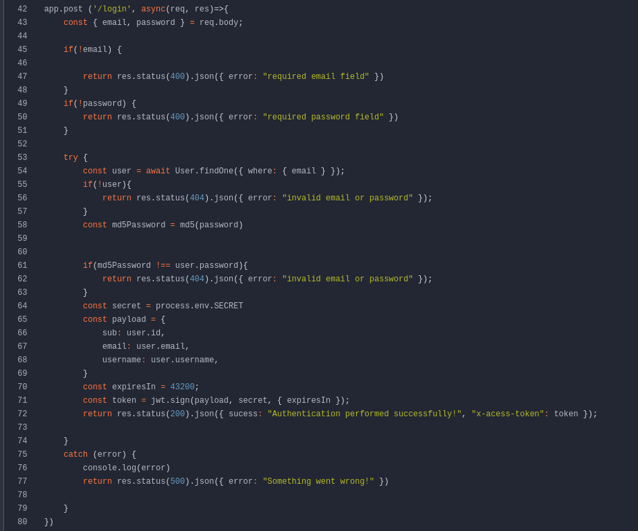
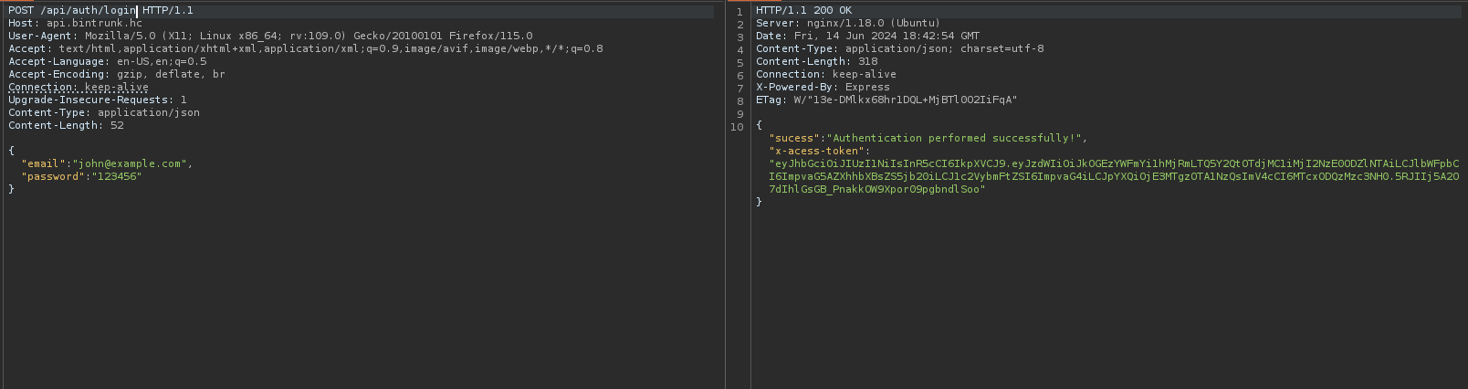

After obtaining the token, we can access the route /api/v1beta/users, passing the header Authorization: Bearer <token>.
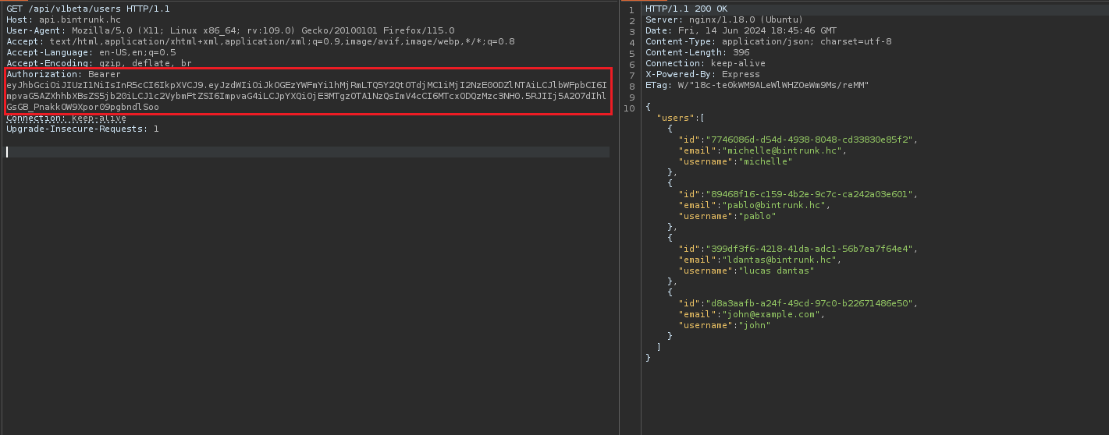
After analyzing the file /controllers/api/user.js, we identified a BOLA (Broken Object Level Authorization) vulnerability. This vulnerability allows us to change the password of any user by providing the corresponding uuid.
Since we previously listed the users, we have access to their uuids, which makes it possible to change the password of user ldantas.
By reviewing the code in /controllers/api/files.js, we notice that it is possible to list and read user files using the uuid obtained through the JWT token (req.user.id). Therefore, we need to change the user's password and then log into that account to obtain the corresponding token.
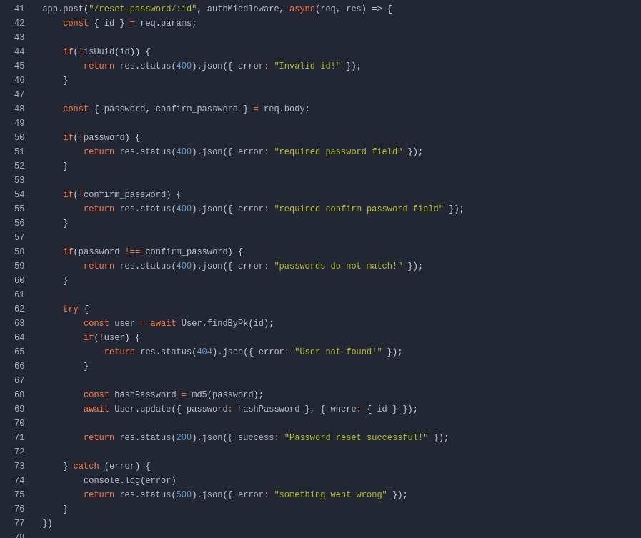
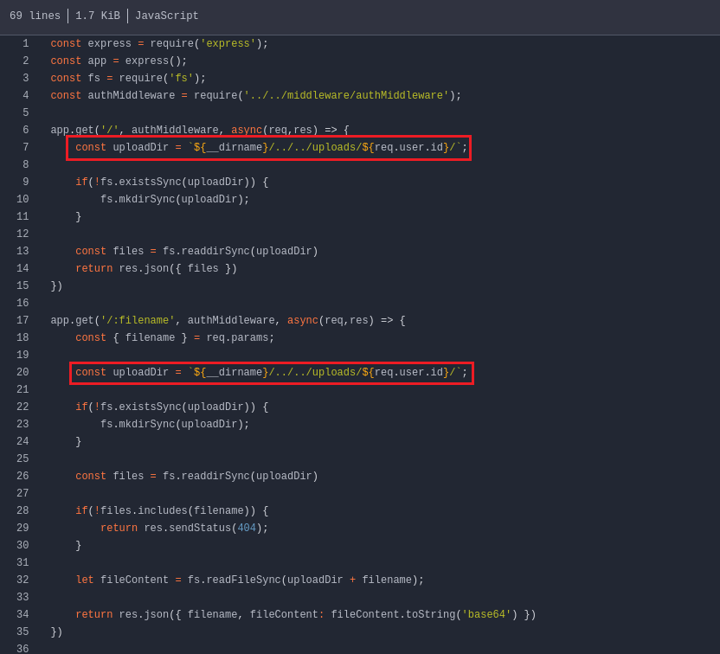
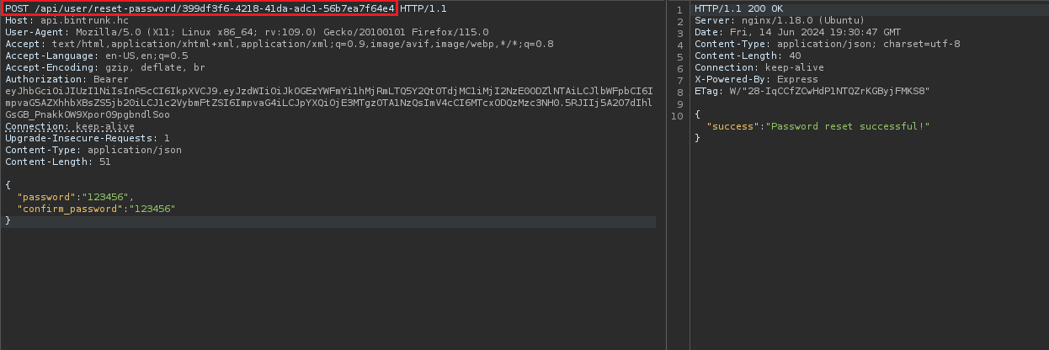

After updating the password of user ldantas, we can log in to obtain the token.
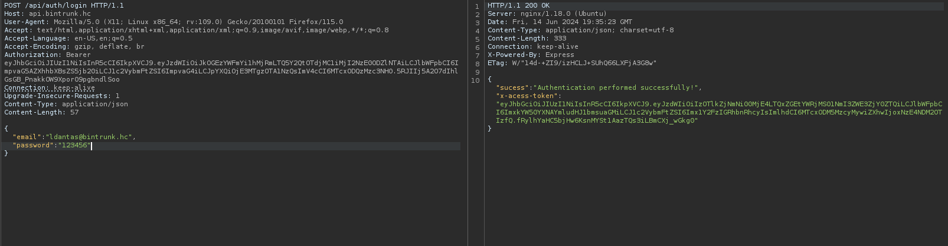
After acquiring the token associated with user ldantas, we can send a request to the route /api/files to list that user’s files.
When listing the files of user ldantas, we identified a file of interest called ala7u-ldantas.pem. We can send a request to /api/files/ala7u-ldantas.pem to obtain the contents of that file.
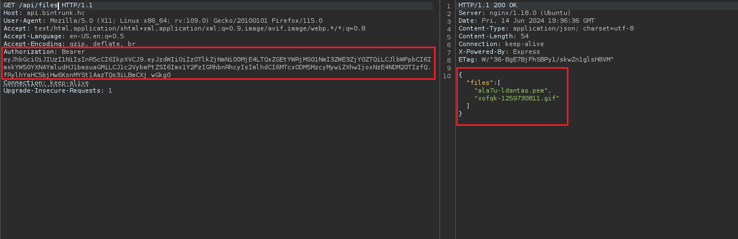
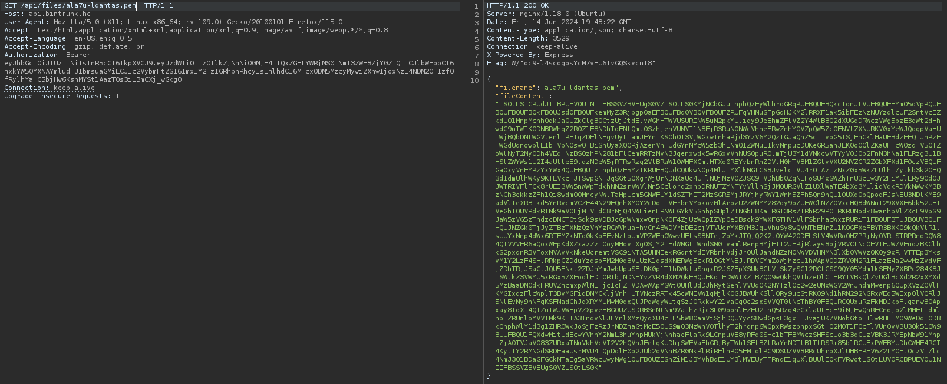
We observe that the file content is encoded in base64. After decoding the file, we identify that it is an SSH key. Therefore, we can assign the correct permissions to this key and use it to gain access to the server.
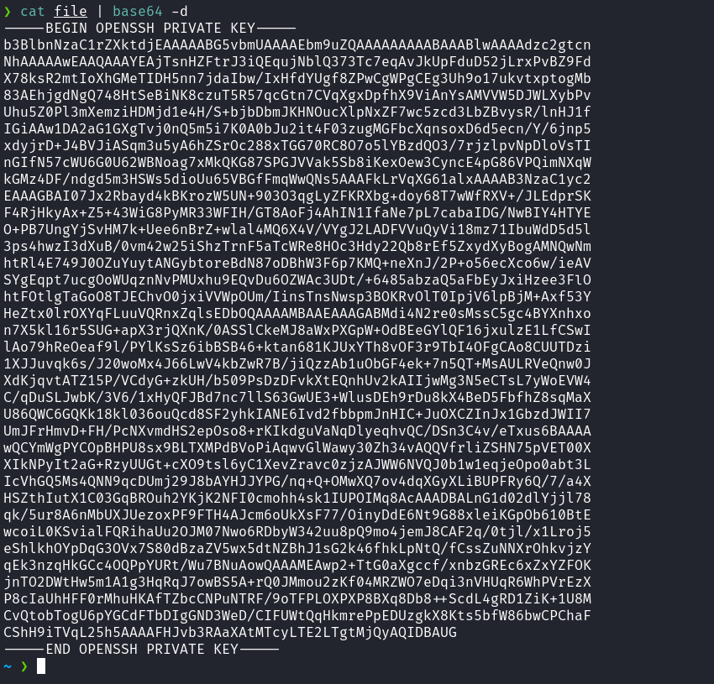
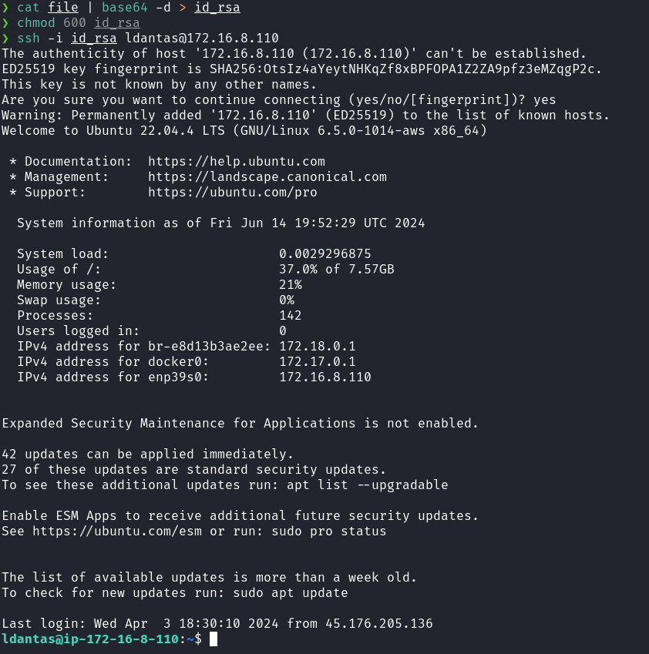
By listing the home directory of user ldantas, we are able to obtain our first user flag.
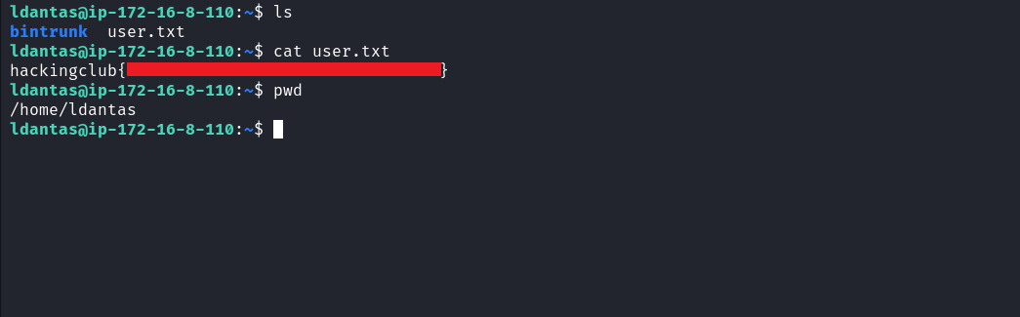
After obtaining our first flag, we need to escalate our privileges to the root user.
By accessing the directory /opt/webhook, we find the file app.py. Upon examining this file, we notice that it executes /opt/webhook/webhook.sh when we access the route /. Additionally, it is important to highlight that we have write permission on the file webhook.sh.
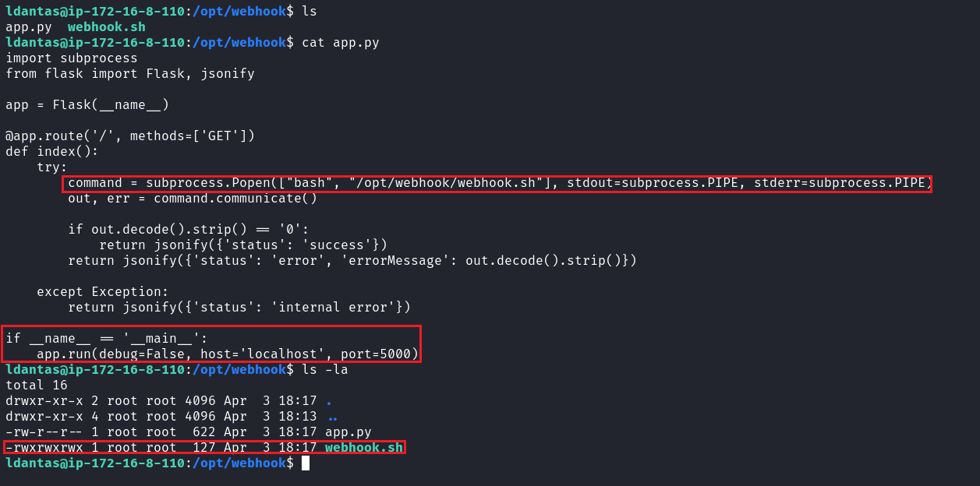
By executing the command ps aux | grep "root" to list processes associated with the root user, we can identify that root is executing the file app.py. With this information, we can edit the file webhook.sh and insert a command that grants SUID permissions to the Bash binary.
Then, we simply need to send a request using curl to 127.0.0.1:5000 to execute our malicious code.
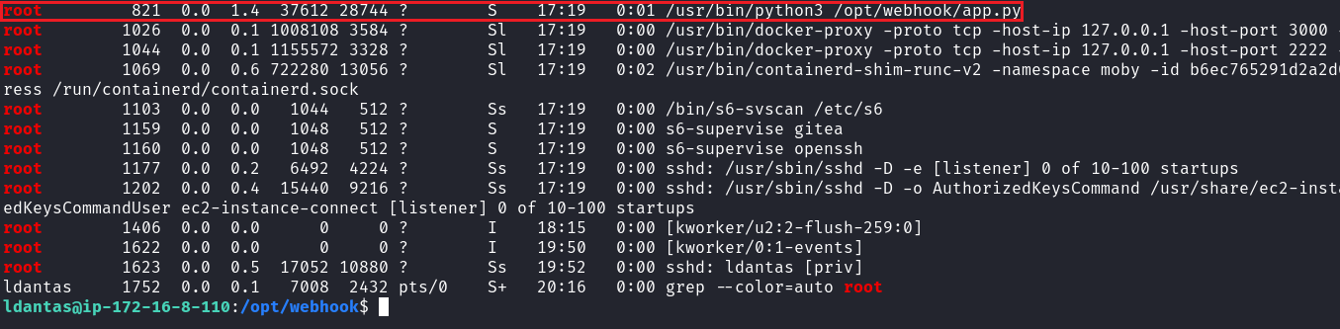
We can edit the webhook.sh file and insert the following command:
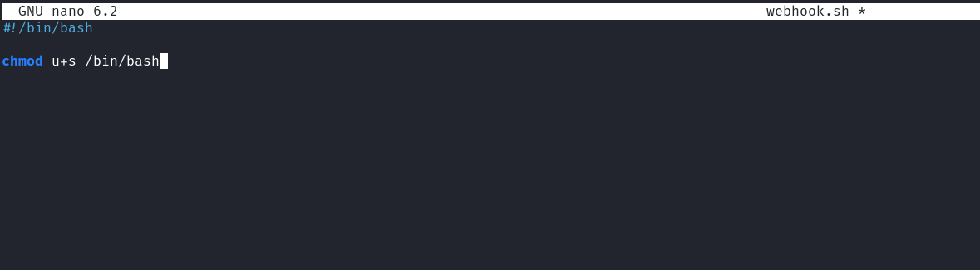chmod u+s /bin/bash

After saving the file, we can send a request to 127.0.0.1:5000. After that, we just need to execute bash -p to run the Bash binary with the permissions of the binary owner, which in this case is the root user.
This way, we obtain our final flag.
